Experiment worksheet

3.1 Water can change state

Pages 48–49 and 184

Challenge 3.1A: Three states of water

What you need:

large test tube, tap water, Bunsen burner, heatproof mat, wooden test tube holders, ice cube, copper wire (approximately 8–10 cm long), pliers

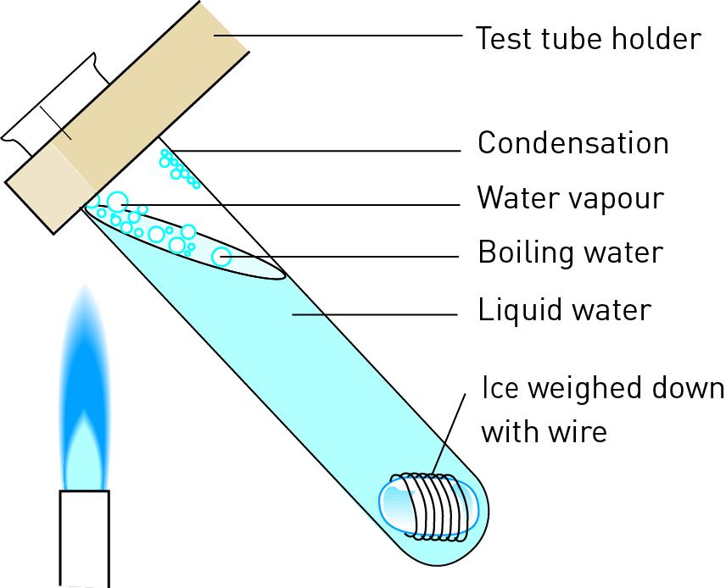What to do:

1 Collect an ice cube that will fit into a test tube.

2 Wrap copper wire around the ice cube so that it will sink in the water.

3 Pour tap water into the test tube until it is one-third full. Drop the ice cube with the wire around it into the water.

4 Gently heat the water at the top of the test tube. (With the ice cube in it, the test tube should be half to two-thirds full.)

Question:

1 Did you manage to have ice and boiling water in the same test tube? Explain how this could happen.

Experiment worksheet

3.1 Water can change state

Pages 48–49 and 184

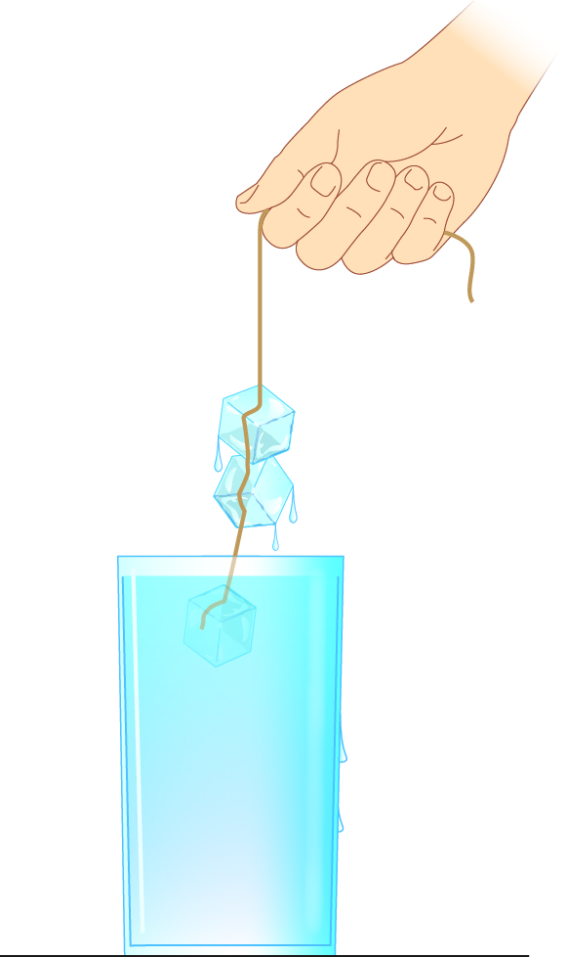Challenge 3.1B: Ice cube necklace

What you need:

some ice cubes, a glass of water, a piece of cotton string, salt

What to do:

1 Float a few ice cubes in a glass of water.

2 Wet a piece of cotton string with water. Lay the string on top of the ice cubes.

3 Sprinkle salt over the string and wait approximately 10 seconds.

4 Now lift the string and the ice cubes will be stuck to it. You’ve just made a cool ice cube necklace!

Questions:

1 Is the ice a solid, a liquid or a gas? Provide evidence to support your reasoning.

2 The salt lowers the freezing point of the ice for a short time, before it refreezes. Define:

a melting

b freezing.

Experiment worksheet

3.2 Water cycles through the environment

Pages 50–51 and 185

Experiment 3.2: What if the temperature were increased in the water cycle?

Aim

To design and create a model of the water cycle.

Materials

• Large clear plastic bowl

• Plastic wrap

• Small weight

• Smaller container, such as the bottom half of a yoghurt pot

• Water

• Large elastic band or string and tape

Method

1 Place the small container in the middle of the large clear bowl.

2 Pour a little water into the large bowl, being careful not to get any in the small container.

3 Cover the bowl with plastic wrap and fix the plastic wrap to the rim of the bowl with either a rubber band or a tight piece of string.

4 Put a small weight on top of the plastic wrap in the centre so that it hangs over, but does not touch, the smaller container.

5 You have now created a portable water cycle. Place your water cycle in partial shade under a tree. Record the time it takes for water to appear in the small container for each model. Record your observations too.

Inquiry: What if the temperature was hotter in the water cycle?

1 Write a hypothesis for your investigation.

2 What (independent) variable will you need to change to test your hypothesis?

3 What (dependent) variable will you measure and/or observe?

4 Name three variables you will keep the same or control.

Results

Record your measurements in a table in the space provided.

|  |
| --- |
|  |

Discussion

1 Describe the movement of the water as it continues to collect on the plastic wrap.

2 Can any of the water escape from your mini water cycle model? How does this compare with the actual water cycle?

3 Give reasons why your model is or is not an accurate representation of the real water cycle.

4 Describe any modifications that you could make to improve the design of your water cycle model

Conclusion

What do you know about the water cycle?

Experiment worksheet

3.4 Human management affects the water cycle

Pages 54–55 and 186

Challenge 3.4: Can you reduce the evaporation of water in irrigation channels

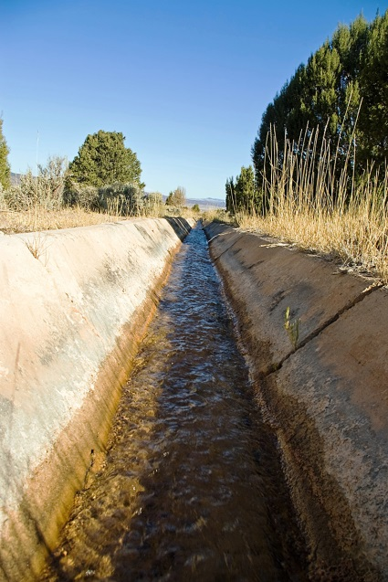Design brief

The Mulwala Canal in the River Murray region of NSW discharges approximately 9000 million litres of water a day. Over 700 000 hectares of land is irrigated from 2880 km of channels in the area.

These open channels allow a lot of water to evaporate before a single drop reaches the plants. Prepare a report that describes a cost-effective way to prevent the loss of water from the irrigation channels.

Criteria restrictions

1 All materials must be available in Australia.

2 All prices must be in Australian dollars.

Questioning and predicting

1 Research the average width of the channels.

2 What materials could you use to replace 1 metre of channel?

3 How much would it cost for this material?

4 Is there a cheaper material that could do the same job?

5 What is the cost of the materials for a 1 km length of channel?

6 How much would it cost for 2880km of channels?

Processing, analysing and evaluating

1 How did the cost of your design compare with that of other students’ designs?

2 Describe one feature of your design that was an improvement on other students’ designs.

3 If you were doing this experiment again, what feature would you change? Explain.

Communicating

Present the various stages of your investigation in a formal experimental report.